Reading Csv file using Aws S3 through Event Triggering

1.first we write code in Vscode using Import of Boto3, Pandas and stringIO

Below code:

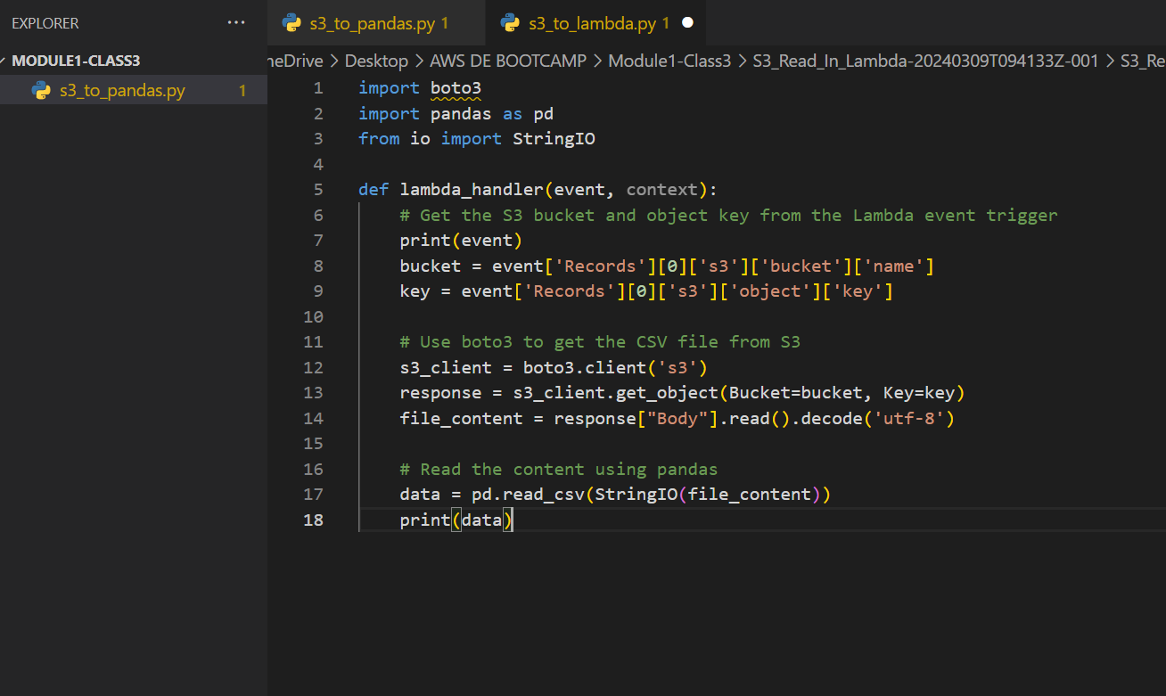

Path: C:\Users\saikumar\OneDrive\Desktop\AWS DE BOOTCAMP PRACTICE VSCODE\Module1-class3

2. Next Create Lambda function -> lambda_function-for-s3-to-pandas -> we can give any name

3.open the code part of Aws lambda function and replace the code by our code i.e s3-to-pandas.py or we can also upload vscode file by Zipping it .

For uploading a zip file we can upload from top right corner

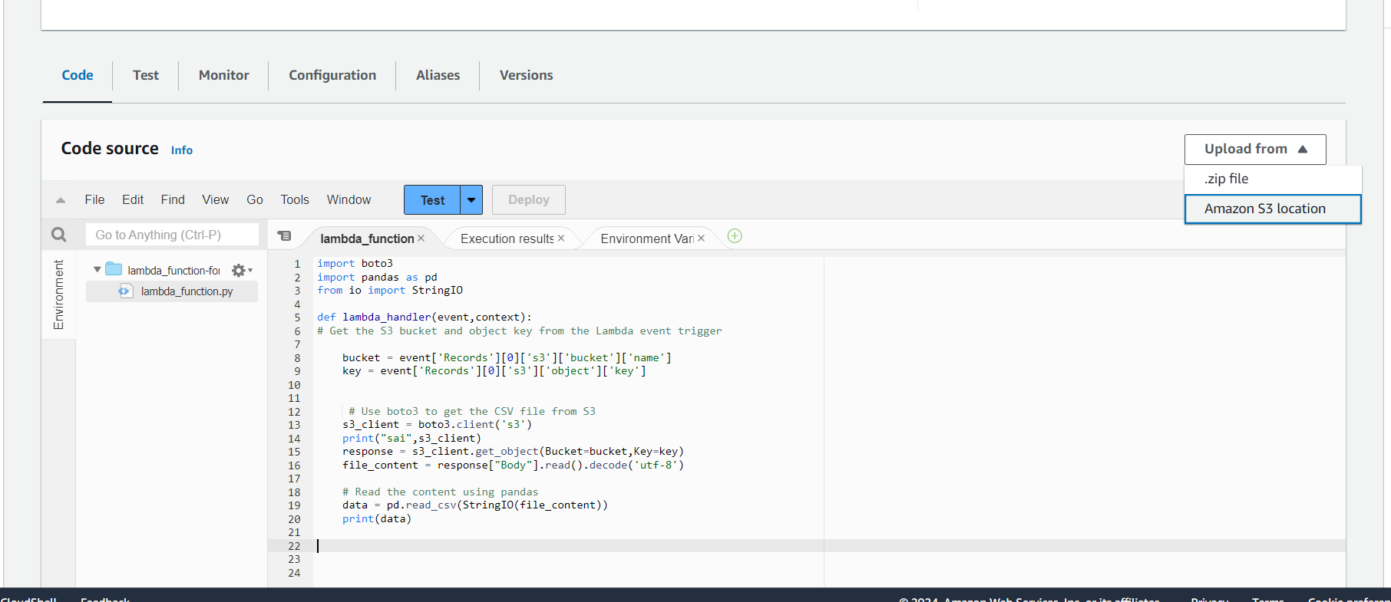

4. Next change the timeout to 1 min using Edit this is optional or based on requirement as well other settings if needed

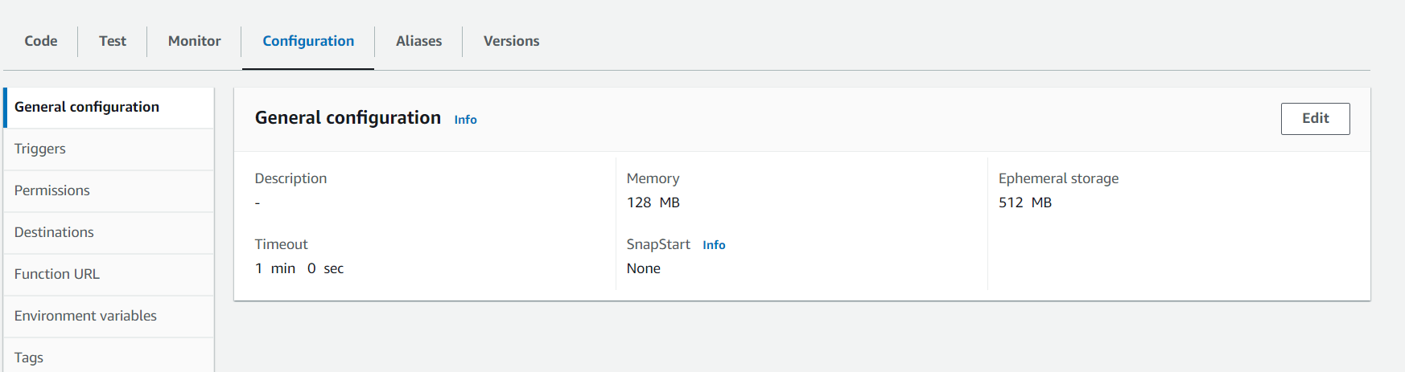

5. The Boto3 and Io libraries are inbuilt in Aws so no need to import or install but for pandas we can add pandas library as layer from AWS layers

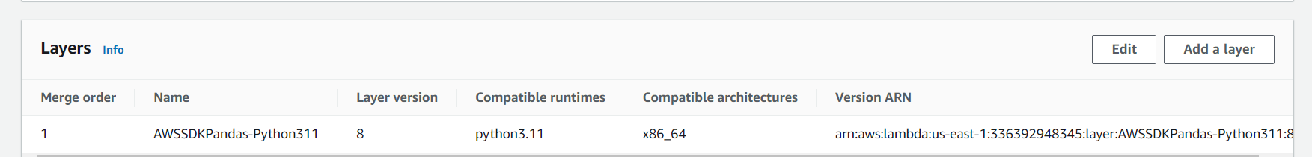

Click add a layer chose from aws layers or we also choose custom layers and in that choose pandas related layer and add it

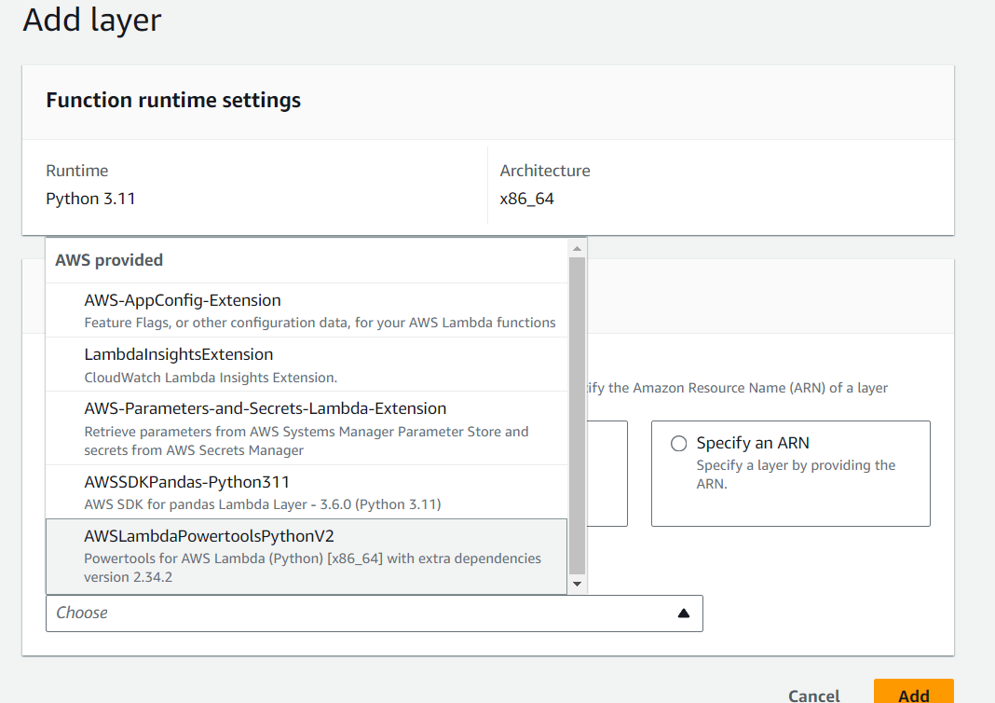

After adding layer it will look like u can see the layers below

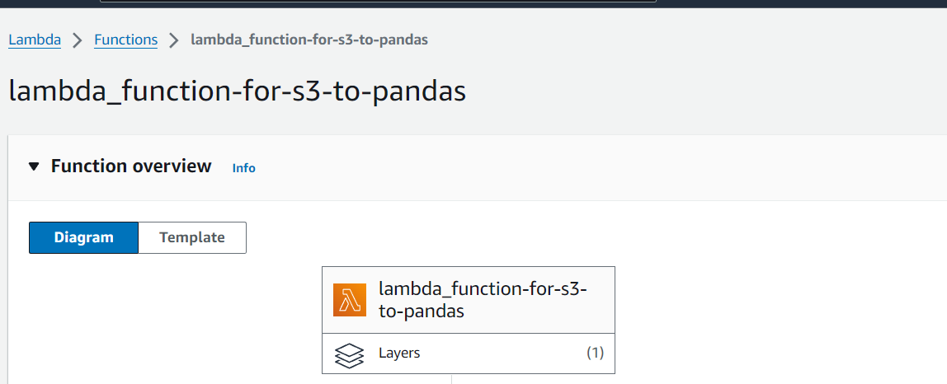

6.Next Create S3 bucket for adding as a Trigger to the lambda function

Click create bucket choose bucket name and Bucket versioning we can Enable and click on create

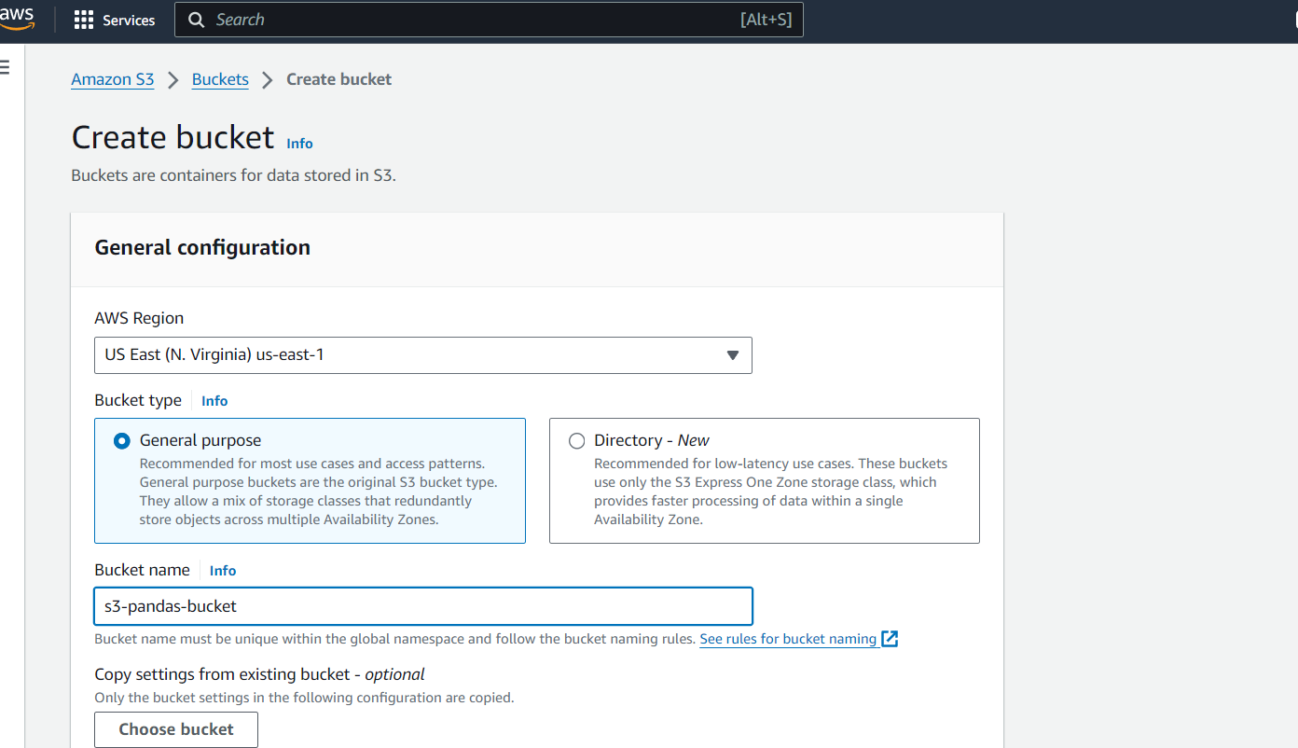

We can see below here we added a folder it’s optional we directly upload a file but don’t upload now

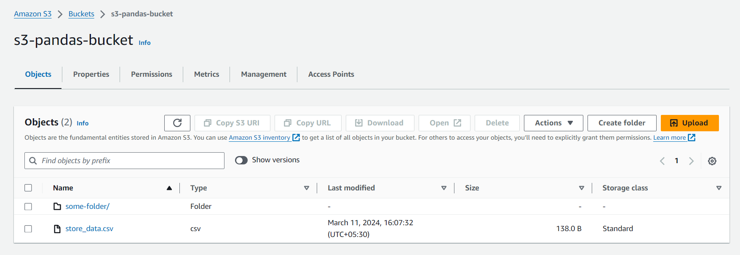

7.Now we will add trigger as S3 bucket and choose all object create event in event types(put,post,copy) etc.. because we needed that events for creating or getting other events also there like delete events but we don’t need them now and finally click on Add

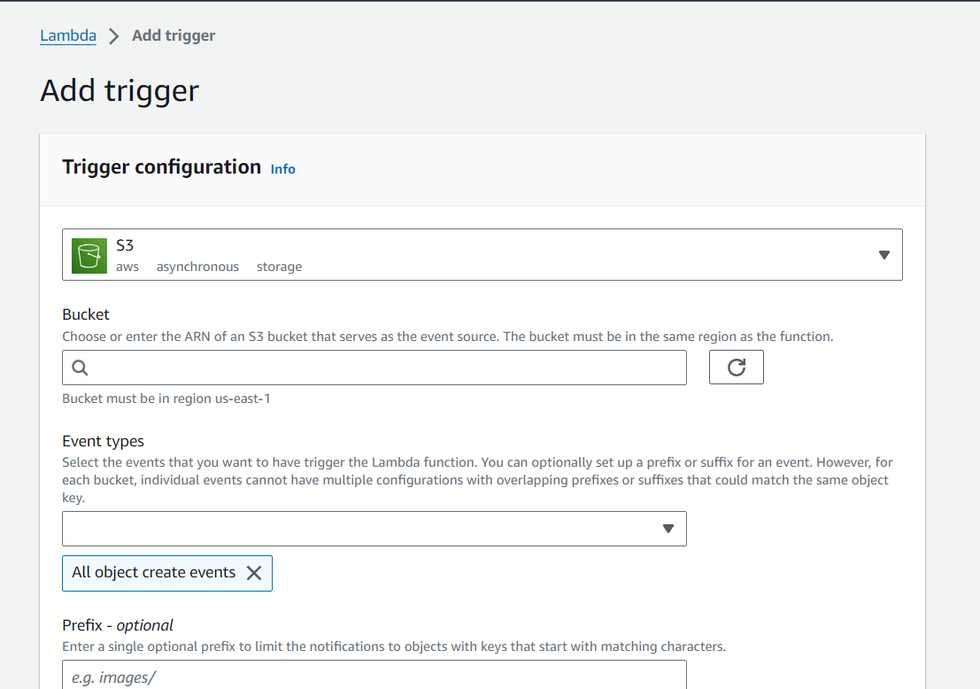

After adding S3 as a trigger for lambda function

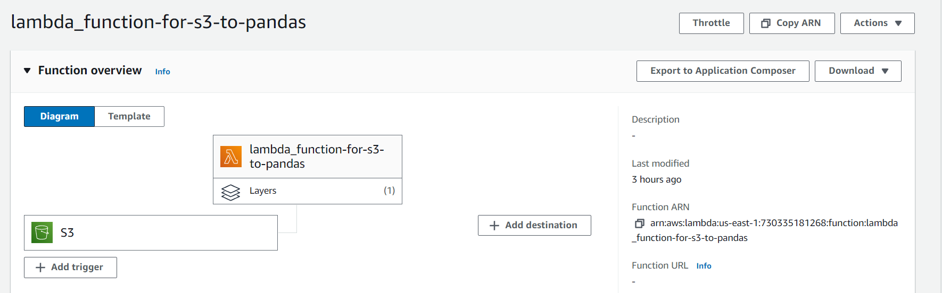

8.Next uploading a file in bucket S3 ex Csv below

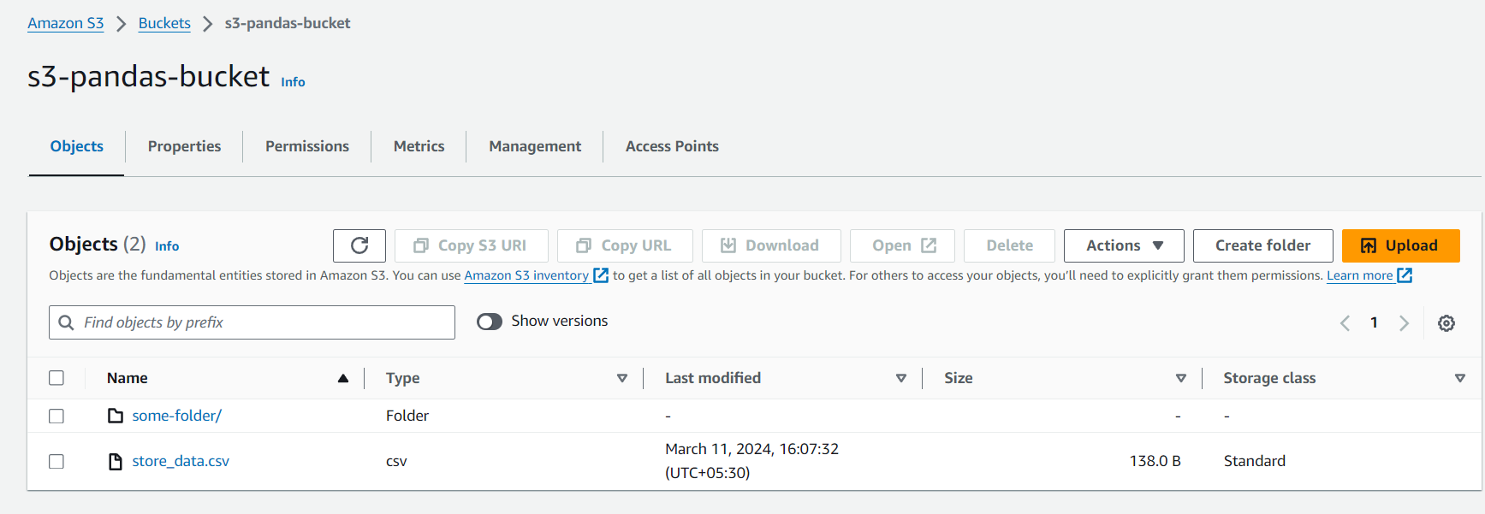

9. Next check IAM role for necessary permissions

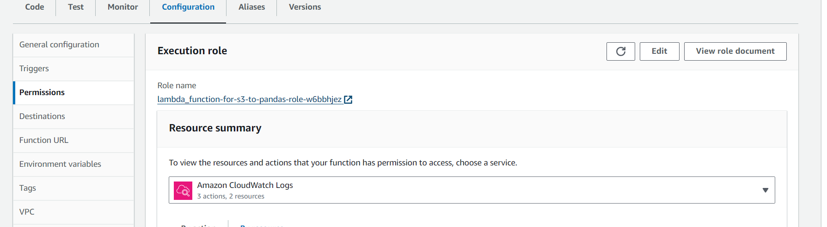

Click role name we will add needed roles from permissions

We have added amazons3 full access through attach policies we can added needed policies

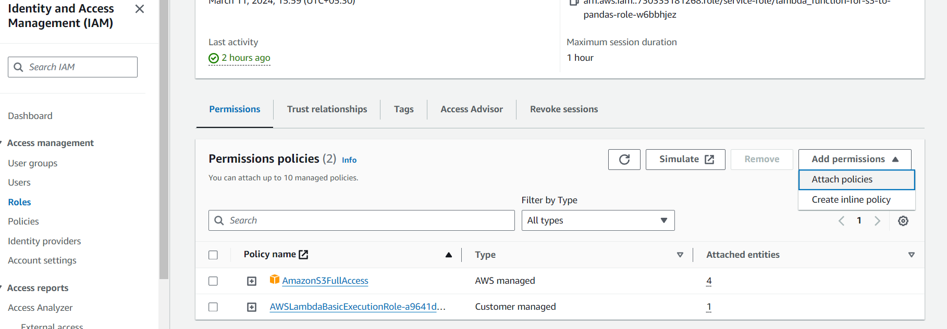

10.After attach policies we can see like this we can search and add required policies

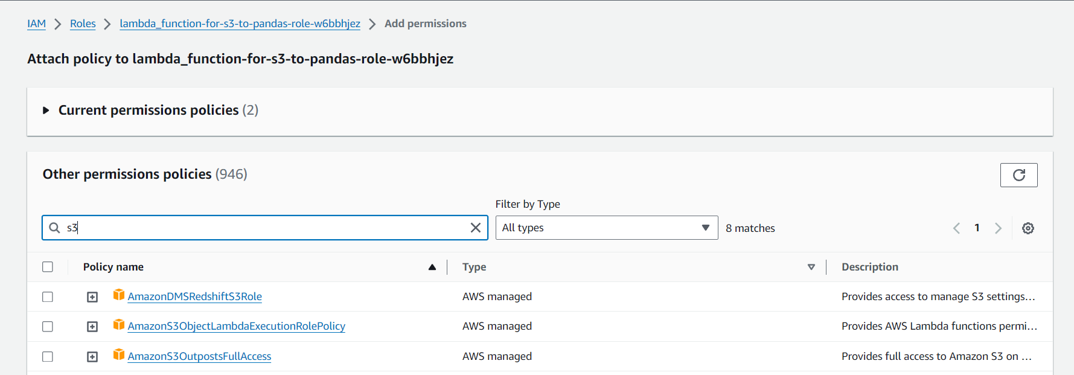

Next run the code by clicking on test configure test event

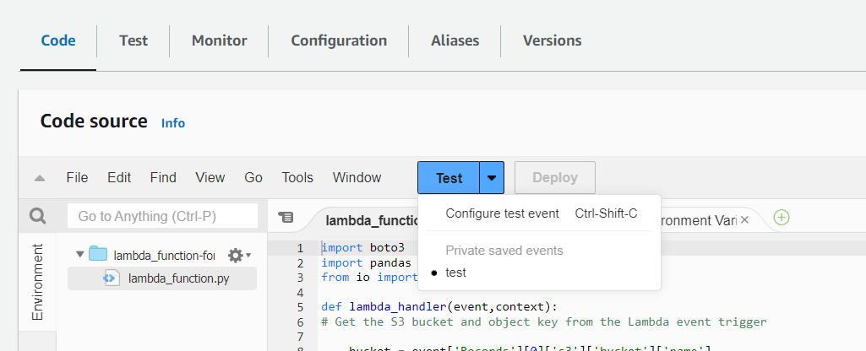

11.Click on create event and here we edited event json as per our events like bucket and object names

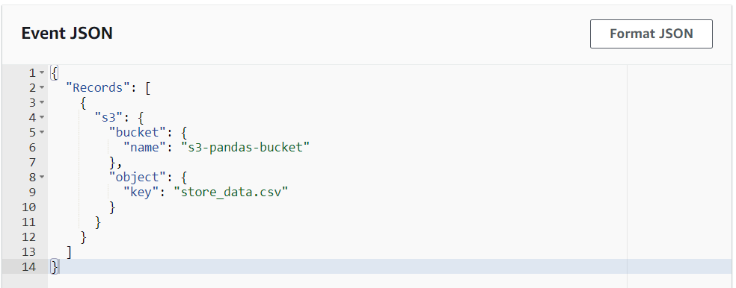

Next click on save u can see below screenshot

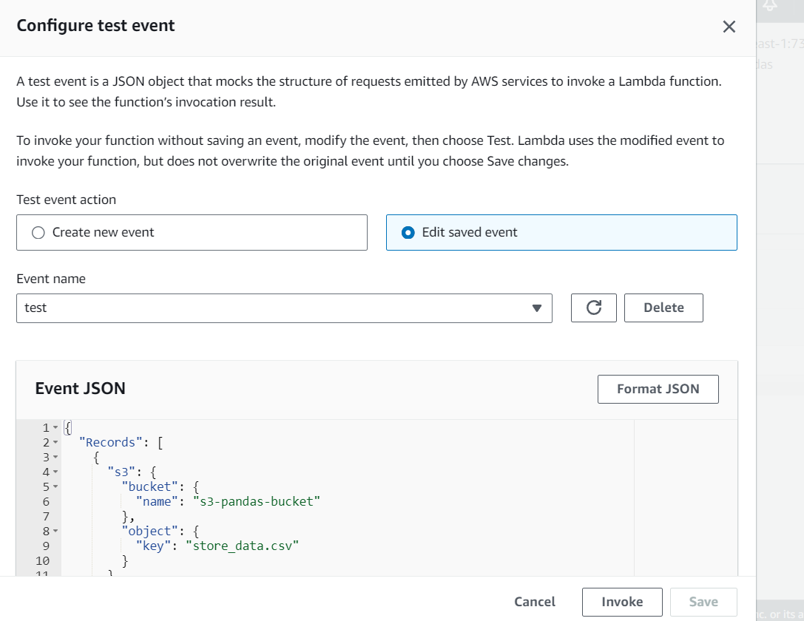

12.After this test or run the code see Exection results

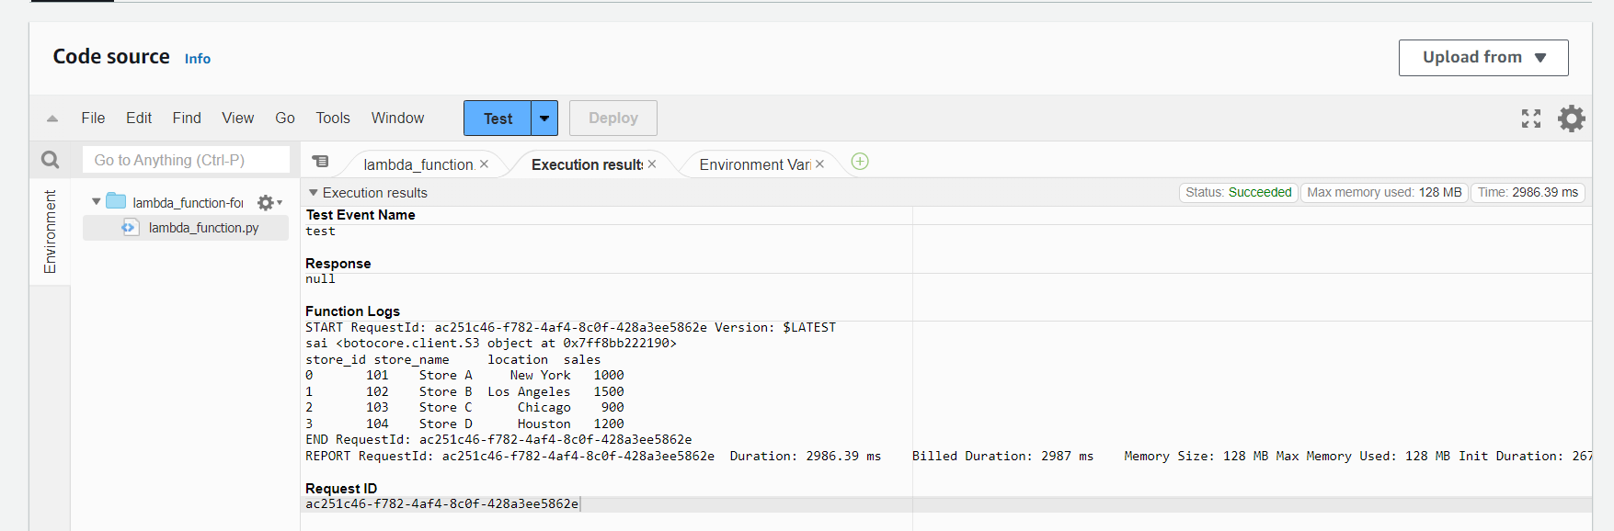

13. now click on Monitor we can see Cloud wwatch metrics below –> Next click on

View Cloud watch logs

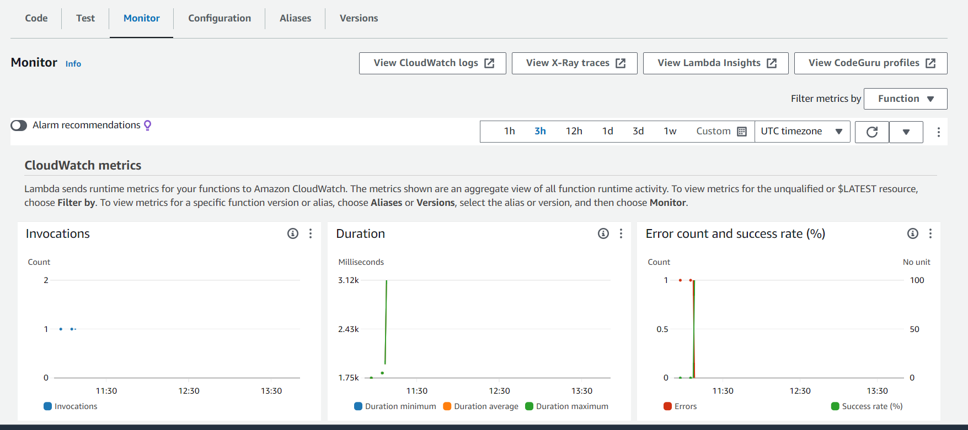

Cloud watch logs are below scroll down to Log streams and we select latest one

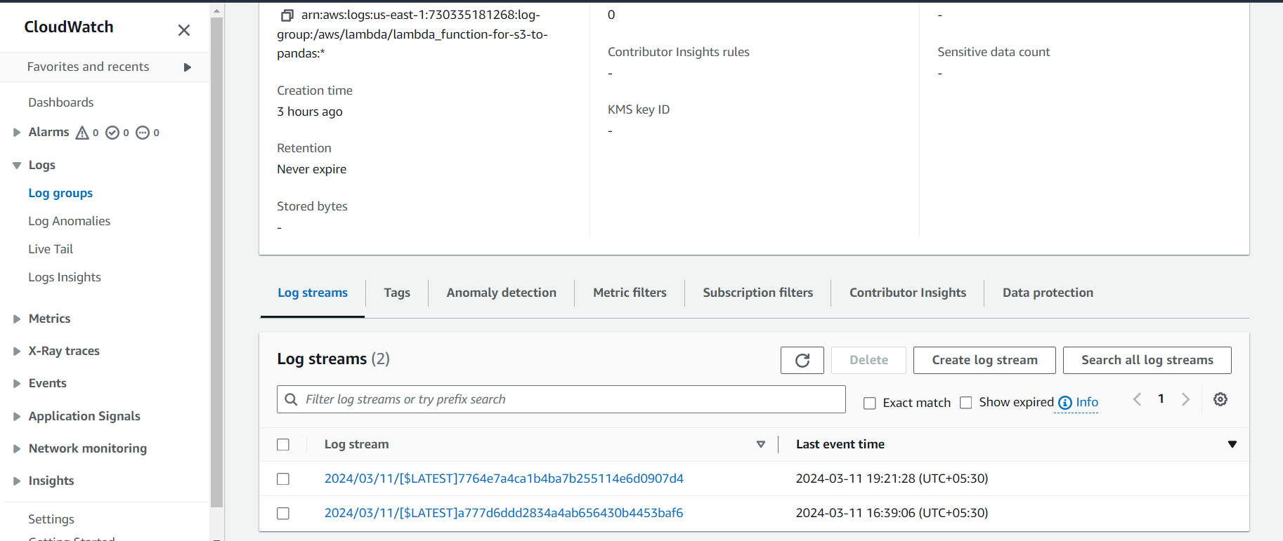

Next we can log events 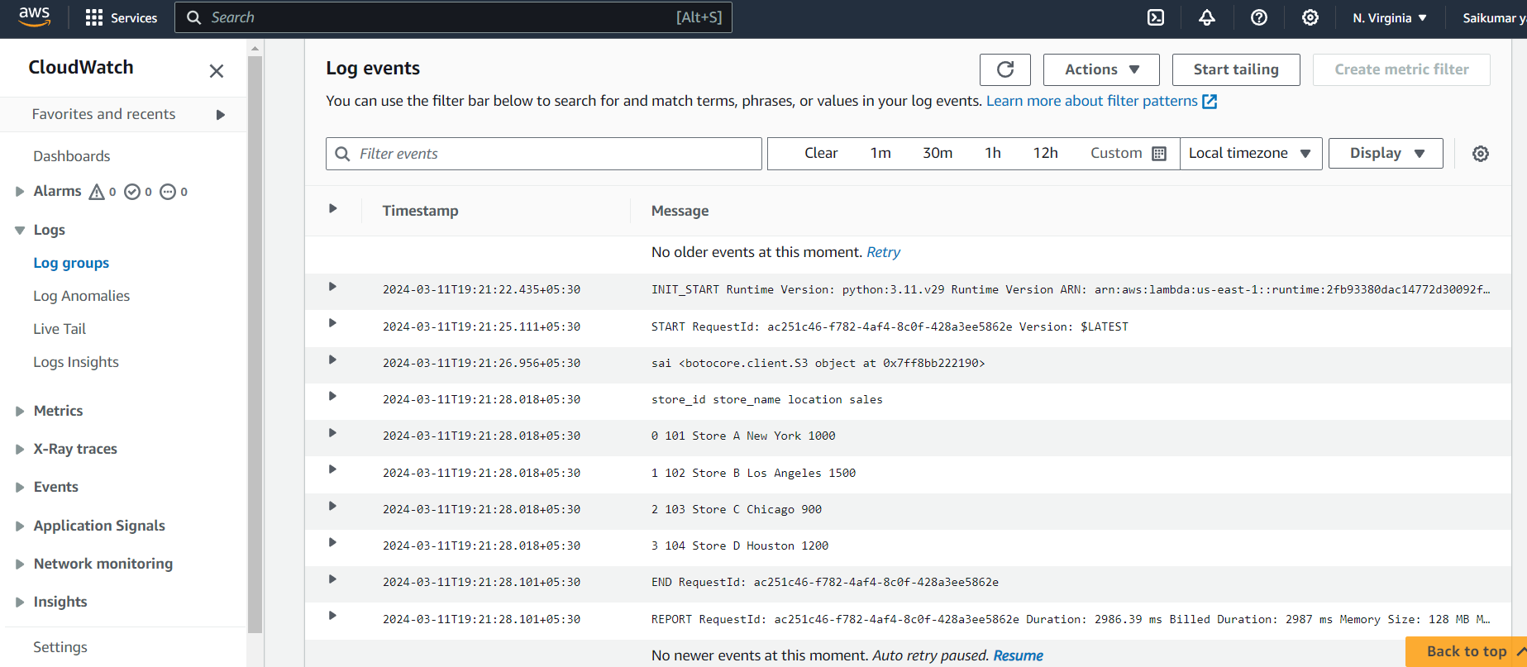

So whenever a file uploads in s3 bucket the aws lambda function trigger with trigger event and we can see the events in cloud watch as well in code execution results